**Message from Mr Wray**

Dear Parents/Carers,

On behalf of everyone at school, I'd like to wish you all a wonderful half-term break. Thank you for being so supportive and welcoming this term, it really is appreciated. I'm really positive and excited about some of the changes ahead for Swanwick Primary. We are working really hard to develop the curriculum and we are confident the developments we have made so far will make a real difference to every child across the school. We've recently rolled out a new writing program called Literacy Tree- the children will love exploring the new high-quality texts. We've also just introduced a new scheme for science which will mean that the children can get practical more often and have lots of fun during science lessons. We've also started to act on the feedback parents/carers have provided so that our communication is clear as well as lots of other things. I feel we've made a good start! Our vision is that one day, Swanwick Primary will be the best in Derbyshire!

Have a great week and we look forward to greeting you on our first day back which is Monday 26th February 2024.

Regards,

Mr. Wray

**Safeguarding**

For any Safeguarding concerns, please call 01773 602268 and ask for the Headteacher stating this is a safeguarding Conversation. In the event that you are unable to speak to Mr Wray, you should ask to speak with our Deputy Designated Safeguarding Leads- Mrs Jo Jilavu, Mrs Helen Stone, Mr Stuart Morris, Miss Jenny Wright or Mrs Mel Walton.

**Friday 16th February 2024**

It is the final day of term! As always, we have a busy Swanwick Story with new term information, key events and celebrations from this term.

There is also information about ‘Tapestry Journal’ for Y2-Y6!

|  |  |
| --- | --- |
| **Events Spring 2** | |
| 26th February | **School reopens to pupils for Spring 2 Term** |
| 4th March | Friends of Swanwick Meeting 7:30pm |
| 5th March | **Year 2 India Day (New Event- see details in this story)** |
| 7th March | World Book Day- Dress up- See details in this story |
| 8th March | Mothers’ Day Stalls after school (Friends of Swanwick Event) 3pm onwards |
| 12th March | Reading Breakfast for EYFS, Y2 and Y5 9am-10am |
| 13th March | Reading Breakfast for Y1, Y3, Y4 and Y6 9am-10am |
| 13th March | Swanwick Stars Concert 6-7pm |
| 14th March | Swanwick Stars Concert 6-7pm |
| 15th March | **Red Nose Day- Dress in something red** |
| 21st March | KS1 Easter Disco 3:30pm- Friends of Swanwick |
| 22nd March | KS2 Easter Disco 3:30pm- Friends of Swanwick |
| 26th March | Parent’s Evening 3:40-6pm |
| 27th March | Parent’s Evening 3:40-6pm |
| 28th March | Break up on Thursday! |
| 29th March | Good Friday Bank Holiday |

**Sports Clubs in Spring 2**

Tuesday - Year 5 and 6 Boxercise

Wednesday - Year 1 and 2 Dance

Thursday - Year 3 and 4 Hockey

*Letters will be sent out via parent mail and places can be booked via parent pay.*



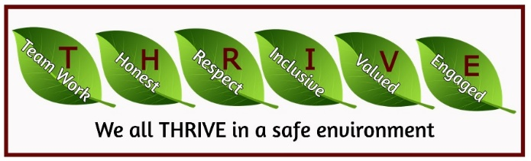



**Celebration Assembly on Fridays- Spring 2**

As detailed in the last Swanwick Story, you will get a Parent Hub notification on a Wednesday afternoon if your child has been nominated for an award. You or another family member will then be invited to join the assembly on Friday. Keep an eye out for those secret messages!

**Golden Table at Lunchtime**

The midday supervisor team will be nominating three children a week to have a special lunch on the 'golden' table. The nominations will be for children with excellent manners and for showing excellent behaviours and kindness at lunchtime. We'll also send you a message when your child has been nominated for this.

**What is my child**

**learning in Spring 2 Term?**

You can use [this link](https://www.swanwick.derbyshire.sch.uk/page/curriculum-planning-eyfs-year-6/145694) to click on your child’s year group folder. You can then navigate to ‘Spring 2 Termly Overview’ to see the topic and subject coverage for your child’s learning.

**Who to contact and when?**

As part of our response to your feedback, we have developed our school communication strategy. We now have a new contact page on the website and you can use this to access our Communication Guidance. [this link](https://www.swanwick.derbyshire.sch.uk/page/contact-us/145934)

There are three options, the first two will link to our new communication flowcharts and the final will link to our general office contact page.

[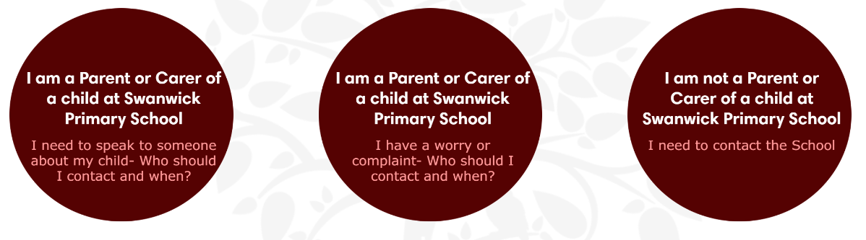](https://www.swanwick.derbyshire.sch.uk/page/contact-us/145934)

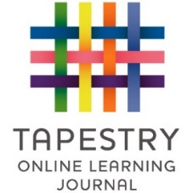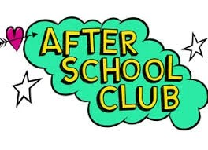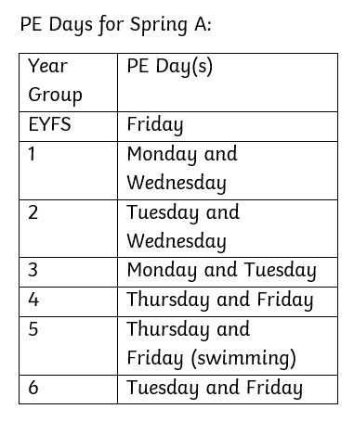

**Spring 2 Termly Plans**

**PE Days- Spring 2**

**Menu**

Starting from next term, we will be offering children across school a number of different extra-curricular clubs after school.

Our new after school activity offer is on our school website.  [Please click on this link.](https://www.swanwick.derbyshire.sch.uk/page/after-school-clubs-menu/145920)

A Microsoft office forms link to book places will be sent at 7pm on Monday 26thFebruary so places can be booked.  Places will be allocated on a first come first serve basis.

**Tapestry for all!**

Responding to your feedback, we intend to roll Tapestry out across all Year groups. We know many of you identified this as an area we can improve on, and we really want to ensure we act on your feedback. This will be something we develop over the remaining year. Further details to follow!

.

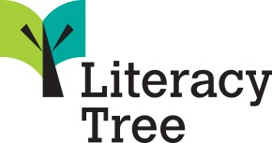

**Science- Developing Experts**

This week, our staff meeting was held by Mrs Hilditch- Science Lead.

We were introduced to a science support programme that will enhance our delivery of Science across the school.

It is called ‘Developing Experts’ and has been created by teachers, for teachers. The lessons look exciting and engaging and the programme also allows children to see what careers they could enter into, linked to the subject they are learning. We hope this increases our children’s aspirations and excitement around Science, whilst equipping them with the progressive knowledge to understand the world around them. We will share more details in the new term!

**Curriculum Developments**

**English- Literacy Tree**

Last week, our staff meeting was led by Mrs Holdsworth and Miss Harris (our Reading and Writing Leads). We are very excited to be launching a new Literacy Scheme called Literacy Tree. The scheme is designed to promote a love of reading and writing. It is jam packed with exciting, contemporary and engaging literature. We are really looking forward to beginning this in Spring 2 and we will share more information and updates in the new term.

**Curriculum Plans and Content**

We are in the process of updating our ‘Curriculum’ Section on the Website. In the coming weeks, you should notice additional information appearing on the website, to give you a better understanding about what your child is learning at school.

Please bear with us, whilst we make these changes.

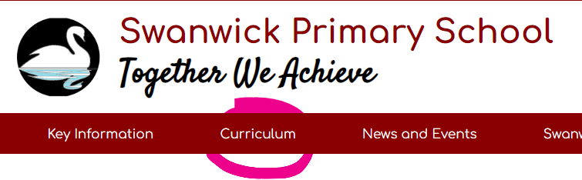





**World Book Day**

Thursday 7th March is World Book Day and we will be celebrating this important event with a book themed day in school. Children are invited to bring their favourite book into school to share with the class or with a friend (please put your child’s name inside the book). There will be a World Book Day assembly in the morning followed by various book themed activities throughout the day.

The children are invited to come dressed as a book character. There are many ideas online for simple homemade outfits so please do not go to great expense. Please bear in mind that the costume needs to be warm enough and practical enough to go outside at playtime. We are mindful that not all children enjoy dressing up and therefore they can come in non-uniform as an alternative.

World Book Day is a charity-based project and your child will have bought home a £1 book token this week, supplied through the organization. From the many participating bookshops and supermarkets, they will be able to choose a book for free. Details of the books on offer can be found on the Word Book Day website. <https://www.worldbookday.com/>

During World Book Day, the children will also receive a free book courtesy of the charity ValleyCids and will have the opportunity to enjoy their new book during our mini ‘reading camp’ in the hall.

**World Book Day Competition**

**World Book Day Photo Competition**

During the run up to the event we will be running a competition and entries can be handed in to class teachers from Monday 26th February up until the day. We are looking for photographs of the children reading in unusual locations! Having run this competition previously, we look forward to seeing how creative you can be! The five lucky competition winners will each receive a £5 book token which can be spent at the school bookfair. The bookfair will be arriving on the 11th March and details of the opening times will be sent out via parent mail.

**Y2 India Day**

A late addition to the calendar. Year 2 will be invited to dress up for India Day on 5th March. This day is designed to bring the Year 2 India Topic together and ensure a memorable experience for the children. There will be a Parent Hub message in the new term as a reminder.

**Swanwick Stars Concert Update**

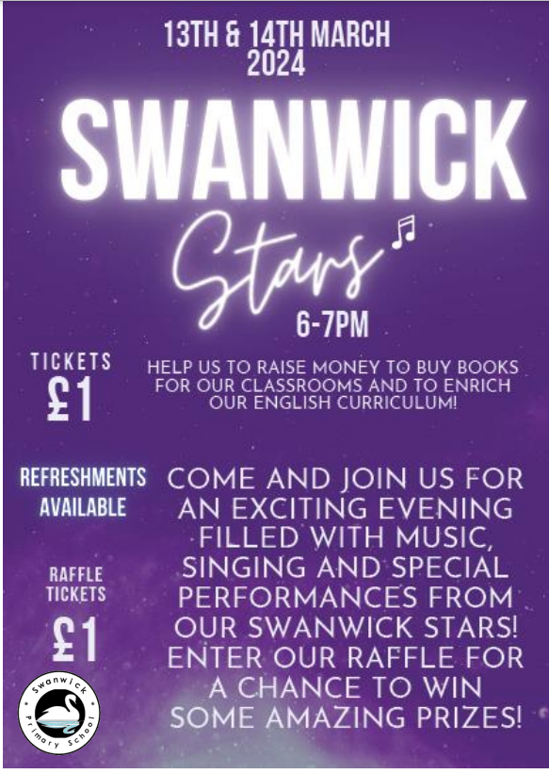

It is not long until we will be holding our annual Swanwick Stars Concert!

Last year, the raffle raised a fantastic amount of money, which we were able to use to buy over 30 glockenspiels, recorders, boom whackers AND a steel drum experience for all children in school!

Tickets and raffle tickets for the Swanwick Stars Concert will be on sale from the office and via Parent Pay after half term. A ParentHub will be sent out with more information soon.

This year, all money raised from the concert and raffle will be going towards new books for the whole school.

*Thank you,*

Miss Harris

Music and Writing Lead

**Red Nose Day**

Red Nose Day is back on Friday 15th March 2024. Swanwick Primary are joining thousands of people up and down the country to raise money for Comic Relief. Whatever we raise, no matter how big or small, we’ll be helping people going through the toughest times of their lives, in the UK and across the world. We have set up a payment on Parent Pay for donations. More information will be shared after February half term, but please note it will be a non-uniform day and the children are invited to come to school wearing red. Mrs Staley



Some of the

amazing prizes

for the raffle

include:

2-night weekend stay at Parkdean Cayton Bay, Scarborough

Clip and Climb voucher

Peak Wildlife Park voucher

Snowdome taboggan voucher

Megazone voucher and many more!





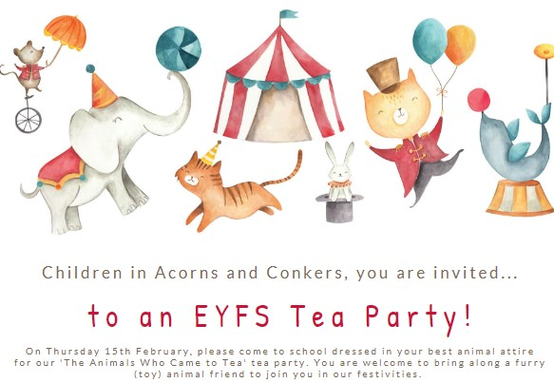

**Learning at Swanwick Primary School**

**Year 1 Explorers**

**EYFS Animal Tea Party Fun**

The children in Acorn and Conker Class have had a fantastic day at their Animal Tea Party. The children spent time preparing a delicious feast of jam sandwiches and decorated biscuits. The costumes looked amazing too!

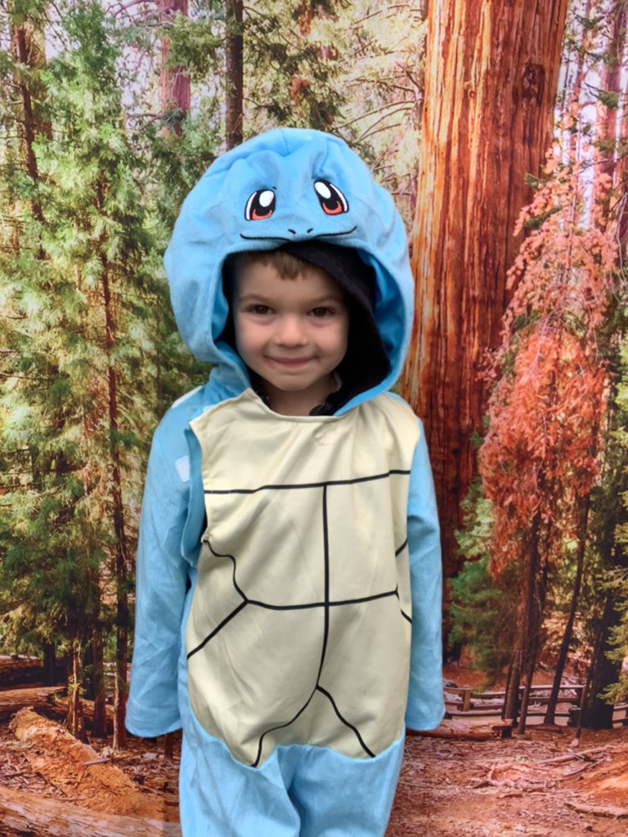



**Learning at Swanwick Primary School**

**Year 1 Explorers**

This week, Year 1 children had a fantastic Explorer Day. The children completed follow up tasks to recount the event, and all talked excitedly about the day. The Classes completed the school orienteering course, collecting symbols along the way. It was a wet afternoon so the hot chocolate at the finish line was very welcome by all!

Here are just a few images from the day.

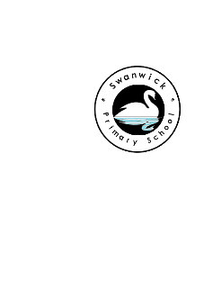



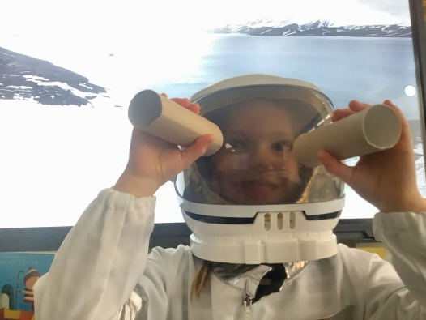

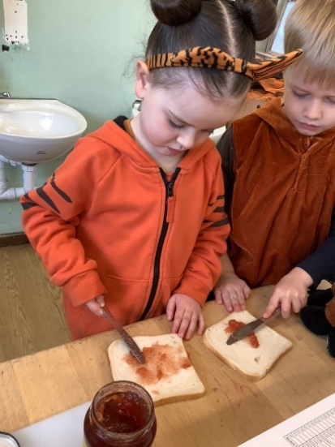

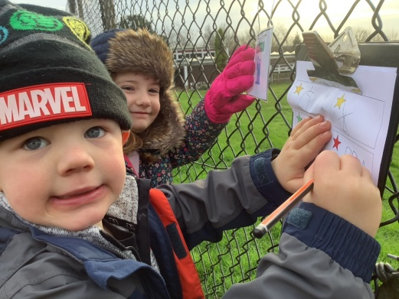

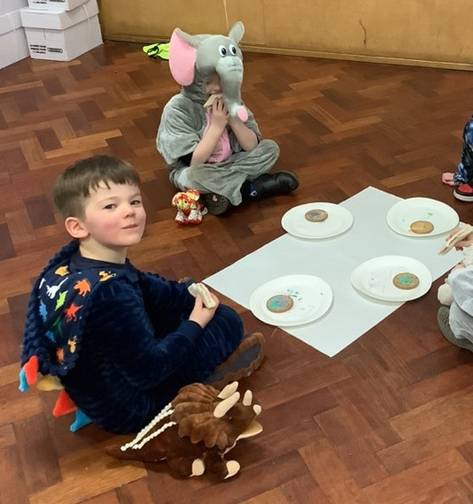

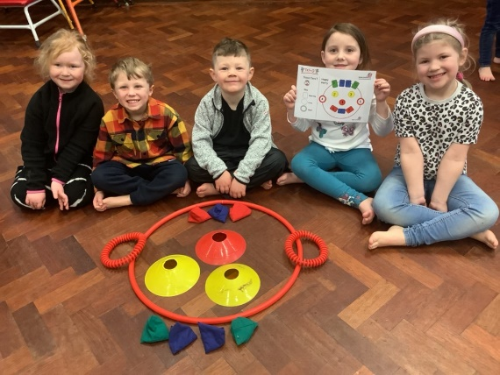

**Year 3 Roman Day Success**

Year 3 thoroughly enjoyed their Roman Theme Day. The children loved making their own Roman laurel wreathes and looked at Roman numerals whilst code breaking. They also looked at Roman baths and where you can find them today. They certainly enjoyed trying different foods that the Romans brought to the empire. What a great day!

**Dodgeball**

Well done to all of the children who have taken part in the dodgeball competitions this term. All children represented the school well and showed excellent teamwork, determination, respect and honesty. Each event was popular with schools from the local area. The Year 4 team finished in 2nd place which was a brilliant result. It was a pleasure taking the children who did the school and themselves proud. Thank you to all of the parents for their support at the events.

We look forward to more competitions after half term.

**Safer Internet Day- Competition Winners**

We have been amazed by the amount and variety of creative entries for our Safer Internet Competition! We’ve had entries such as posters, painting, books and even songs! It’s clear our children want to make the internet a much better place and their ideas were inventive and positive.

Mr. Wray, Mr. Cartwright and members of year 5 and 6 had a very tough time looking through every entry and choosing our winners: well done to everyone who entered!

**Our winners:**

Key Stage 1: Bonnie for her ‘Blew Safety Stories’

Key Stage 2: Harper for her Interactive PowerPoint and poem.

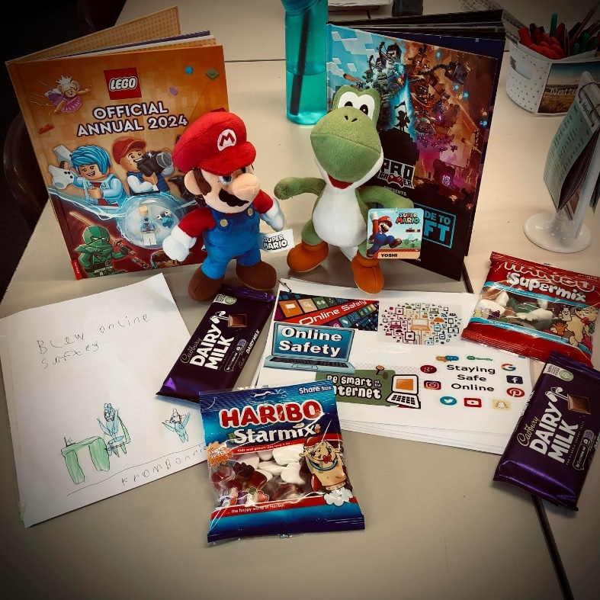

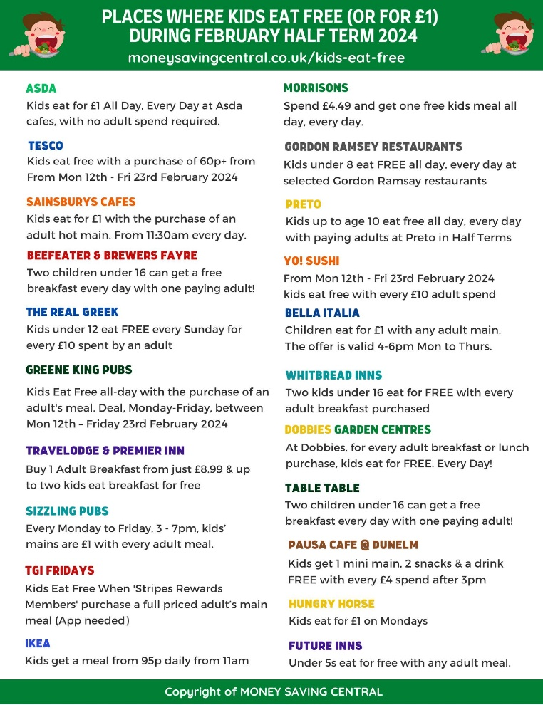

**Happy Half Term!**

We all wish you a happy half term. Make sure you find time to spend as a family and relax!

You can find places that offer free meals for children (or £1) to help spread the pennies!

