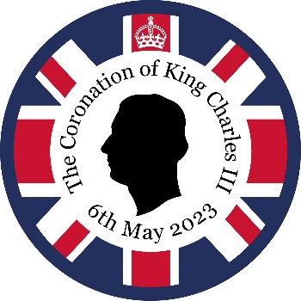
Friday 31st March

Celebrating King Charles III’s Coronation
Friday 5th May, 2023

Dear parents/carers,

As you may know, King Charles III’s coronation is taking place on Saturday 6th May. Swanwick Primary would like to celebrate this momentous event in history by inviting parents and carers to share the afternoon with us on Friday 5th May.

Plan for the afternoon:

Parents and carers are welcome onsite (via South Street entrance) from 1:20pm, and can make their way on to the playground. All children will be brought to the playground at approximately 1:30pm, where activities will commence after a short welcome from Mrs. Jilavu.

After this, you can choose from a variety of exciting activities that you can enjoy with your child/children. Activities will be in several different classrooms, inside the main block, and outdoors (weather pending). You can spend your afternoon how you like with your child, whether that be playing games, participating in craft activities or simply sitting and relaxing. We will provide you with a map and a key so that you can easily navigate around the grounds.

Friends of Swanwick will be serving refreshments in the hall, which will be available for you to purchase throughout the afternoon.

Children will be having a themed lunch at the usual time but feel free to bring snacks with you to share with your children throughout the afternoon. Why not bring a picnic blanket to sit outdoors? We ask that you do not bring any nuts or nut based products into school. Thank you for understanding.

At 3pm, all children will return back to their classrooms. After a register has been taken, you are welcome to collect your child from their classrooms, where they will be dismissed by their class teacher. Children who are not being collected early, can leave/ be collected at normal time. After your exciting afternoon, there will be an ice cream van waiting for you near South Street entrance where you can purchase further refreshments if desired.

If you would like to be part of our fun, free afternoon, please sign up here so that we know how many adults to expect.

Important reminders:

- Please do not bring any food products containing peanuts or any other kinds of nuts.
- Please do not bring any alcohol onsite.
- Smoking and vaping is prohibited onsite.
- You can collect your child/children from their classrooms from 3pm onwards.
- Children will not be allowed to leave site before 3pm.
- There will be an ice cream van outside of school (South Street) for you to buy an ice cream if you wish.
- You are of course welcome to take pictures of your own children, but please do not take photos of other children or put photos of other children on social media.

Non-uniform:
- To make this day even more special, we are inviting children to wear the colours of the United Jack (national flag) – red, white and blue. Children can also dress as a king, queen, princess or prince or as if they were attending a royal ball!

Design a crown competition:

Swanwick Primary is holding a competition to see who can design the best crown fit for a king. You can use any resources to make the crown. Children can bring their crown to wear on Friday 5th May, where we will have a parade to see all of the great designs. We will pick a winner from each year group; we cannot wait to see you showcasing your crowns!

Optional activities to complete at home:

Royally Big Portrait
BBC Children in Need’s Royally Big Portrait is celebrating the historic coronation of King Charles III and children’s creativity.
The Royally Big Portrait is a giant digital portrait of King Charles III that will feature thousands of individual portraits of the King drawn by primary school pupils from across the UK.
Click here to find out more and how to get involved.

Time Capsule

Why not create a time capsule so that you can remember what life was like and what you were doing when King Charles III was crowned?

Click here to find out more and how to get involved.

Decoration Donations

We would love to decorate part of the school grounds with colourful bunting. Do you have any spare bunting or banners at home that you wouldn’t mind donating to celebrate the King’s coronation? If so, please bring them to Mrs Staley’s classroom by Friday 28th of April.

We want this to be a memorable experience for parents, carers and children and I am sure you appreciate that staff are working very hard to make this a special day for all involved.

Thank you for your support,

Mrs C Staley and Mrs V Strong

